**Ncsa**

**Navigating your way through complimentary data sources**

Ecological consultants use a variety of online tools and databases to supplement the data that they collect in the field. In this exercise you will become familiar with key websites used in the industry. The skills you develop here will help you complete the second part of the assignment later on in the course.

**The National Biodiversity Network** 

The NBN is a collaborative partnership created to exchange biodiversity information across the UK. It is a charity and its members include a range of conservation NGOs, environmental agencies and records centres.

* Access the NBN website at <https://data.nbn.org.uk/>. In this exercise we are going to extract records associated with a specific site – so select the LOCATIONS tab.

* Use the “explore by address, postcode or location” option to zoom to a site of personal interest (eg. the house you grew up in, favourite UK holiday destination, favourite walking spot etc).
* You should now see a list of species that have been recorded at your site.

1) How many species in total have been recorded in a 1km radius of your site? ………….

2) How many plant species? …………….

* Click on “view all records” to explore the data in more detail. Use the “Customise Filters” option to try and answer the following questions:

3) Which data provider has contributed the most number of records in your site? How many records have they contributed?

………………………………………………………………………………………………………

4) How many butterfly and moth species? ………………

5) How many beetle species? ………………

Across Europe 194 bird species are considered threatened and have been given protection under the Birds Directive Annex 1[1]. This is the highest level of protection and requires all Member States to ensure the birds survival and to designate Special Protection Areas (SPAs).

* Under the ‘ANALYSE’ tab (in the grey bar) click on ‘Tools’ and select ‘Area Report’. Choose ‘Define new area’ and click ‘Next’. You can now define an area in a variety of ways. Use one of these options to create a new area (or redefine the location you selected earlier). Use the list given in the new ‘My Area’ window to discover if any of the birds in your site are protected.

6) List any bird species covered by the Bird Directive Annex 1.

Some birds are experiencing severe declines within the UK, but are not protected under the EU Birds Directive. The UK red list for Birds of Conservation Concern is a traffic light system that identifies species that are at particularly risk within the UK[2].

* Use the Area Report to view data for your area. See if any of the birds in your site have a “Bird population status –red” (i.e. high concern).

1. List any additional bird species that occur on the red list but aren’t covered by the EU Bird Directive.

The UK Biodiversity Action Plan (BAP) identifies priority species that have been identified as most threatened and in need of conservation action [3].

* Use the Area Report to search for any UK Biodiversity Action Plan priority species.

1. How many BAP priority species have been recorded in your site? (If you have high numbers, you may find it easier to list the numbers in each group)

………………………………………………………………………………………………

………………………………………………………………………………………………

………………………………………………………………………………………………

………………………………………………………………………………………………

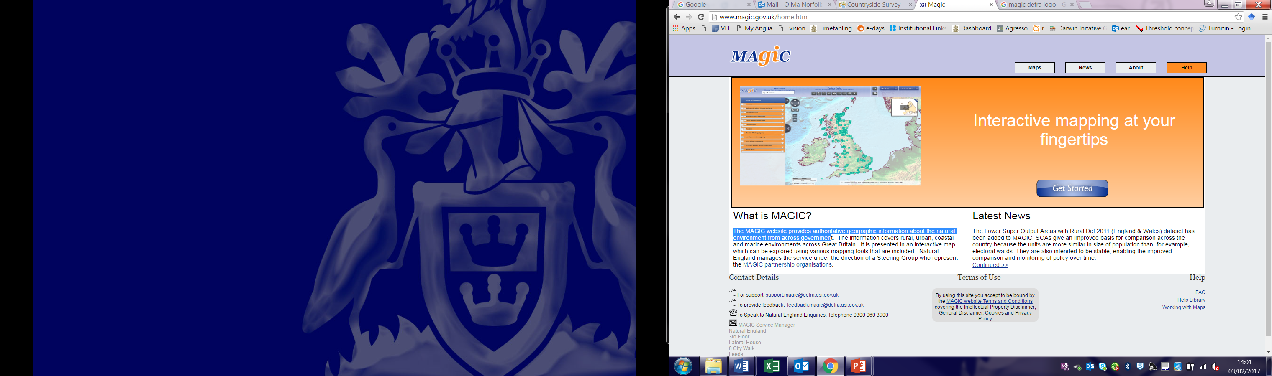**The MAGIC website**

The MAGIC website provides authoritative geographic information about the natural environment from across government. It is presented in an interactive map which can be explored using various mapping tools that are included.

* Access the MAGIC website at <http://www.magic.gov.uk/home.htm>. Click “Get Started” and you will be taken to the interactive map.
* Locate your site of interest (this can be the same as before). You can locate the site using the postcode or by zooming in on the relevant area using the interactive map.

The interactive map can display a range of authoritative geographic information, ranging from administrative boundaries, agricultural stewardship schemes, through to specific habitat types and location of designated areas.

* Under the table of contents (on the left hand side) select the Designations tabs, followed by Land-Based Designations. The map will now outline all designated areas.
* In the Feature Toolbar select the information icon to find out more about the designations that are shown on the map. Click on the ruler icon to measure the distance from your site to the nearest designated area.

1. What is the distance between your site and the nearest designated protected area?

…………………………………………………………………………………………………

1. What is the designation of that protected area? What do the initials stand for? (NNR = National Nature Reserve, SSSI = Site of Special Scientific Interest etc.)

…………………………………………………………………………………………………

For a full summary of Site designations in the UK see: <http://jncc.defra.gov.uk/page-1527>

* Under the table of contents deselect the Designations tabs. Select the Habitats and Species tab. Within this highlight woodland habitats.

1. Is there any woodland habitat in the vicinity of your site? How much of this is classified as ancient woodland?

…………………………………………………………………………………………………

1. Using the Designations tab, can you figure out who manages this woodland?

…………………………………………………………………………………………………

(If there is no woodland present, feel free to explore other habitat types)

Wicken Fen is a Nature Reserve in the North of Cambridgeshire (Wicken, Ely CB7 5XP). Using a combination of the two websites, can you answer the following questions -

1. What are the site designations of Wicken Fen? List any abbreviations in full and state whether any designation is local, national or international.

………………………………………………………………………………………………………

………………………………………………………………………………………………………

………………………………………………………………………………………………………

………………………………………………………………………………………………………

1. What proportion of bird species observed around Wicken Fen are under European Protection?

………………………………………………………………………………………………………

………………………………………………………………………………………………………

1. Wicken Fen is home to two species of bumble bee that are listed as priority species under the UK Biodiversity Action Plan. What are their names?

………………………………………………………………………………………………………

………………………………………………………………………………………………………

………………………………………………………………………………………………………

You should now be more confident at extracting data from the NBN and MAGIC websites ☺

These skills will be useful to any of you considering careers in ecological consultancy…

… And will benefit all of you in Part 2 of the Assignment!

1. **References and useful websites**

   European Commission (2017) The Birds Directive. http://ec.europa.eu/environment/nature/legislation/birdsdirective/index_en.htm
2. BTO (2017) Birds of Conservation Concern 4: the Red List for Birds. http://www.bto.org/science/monitoring/psob
3. JNCC (2017) UK BAP priority species. <http://jncc.defra.gov.uk/page-5717>

   National Biodiversity Network -<https://data.nbn.org.uk/>.

   MAGIC website - <http://www.magic.gov.uk/home.htm>